Artiq-7 Installation Windows

Installing Artiq v7.8:
- Ensure that anaconda version of at least 4.8.3 has been installed on the PC.
- Open Anaconda prompt.
- First you need to ensure that the channels you call the packages for download can be nicely extracted by conda. Particularly llvm-tools and lld create trouble by downloading in a different file format for decompression. You need to keep the artiq’s m-labs channel at the higher priority followed by the anaconda channel. Delete any defaults that may exist.

Add channels from above (high priority):
conda config --prepend channels anaconda
conda config --prepend channels https://conda.m-labs.hk/artiq

This leaves the mlabs link at highest priority. See conda cheatsheet for more commands. We will use the mlabs link and anaconda primarily to get the following order of channels. After the top two the others don’t matter.
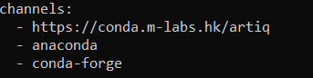

- Create artiq environment, say artiq_7:
conda create -n artiq_7 artiq
This will have created a new environment. We will be working with the Kasli’s IPv4=192.168.1.70 , so make sure that the PC to which it is connected has the ethernet IPv4=192.168.1.1 or so, and the subnet mask address= 255.255.255.0

- If you have an artiq package that has device_db.py (like from /artiq_new_installation_linux in the network drive which has the latest config of our Kasli), then you can navigate to that folder, activate artiq_7 and then run:
artiq_coremgmt config read ip
Or artiq_coremgmt log
(which may or may not respond, even though pinging to the Kasli IP works)
for confirming the connection.

Installing oitg and ndscan:

- Now that the artiq environment is created, you can create a duplicate environment artiq_7_ndscan:
conda create -n artiq_7_ndscan artiq_7
- Create a cloned repository of oitg and ndscan in the folder containing the device_db.py file by the command:

git clone <github repository link oitg>
git clone <github repository link ndscan>

- Activate conda environment artiq_7_ndscan with:
conda activate artiq_7_ndscan

- Go into the oitg folder and run:
python setup.py develop

- Go into the ndscan folder and run:
python setup.py develop

Now both the libraries should be visible under this environment.
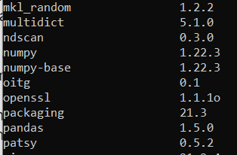
- Go to the folder with the device_db.py file and run:
artiq_master
- Similarly in another terminal in this same folder run:
artiq_dashboard -p ndscan.dashboard_plugin

You should see the Artiq dashboard appears. RabiFlopsim.py should also be working. You can also check if the other devices to which Kasli is connected to works.
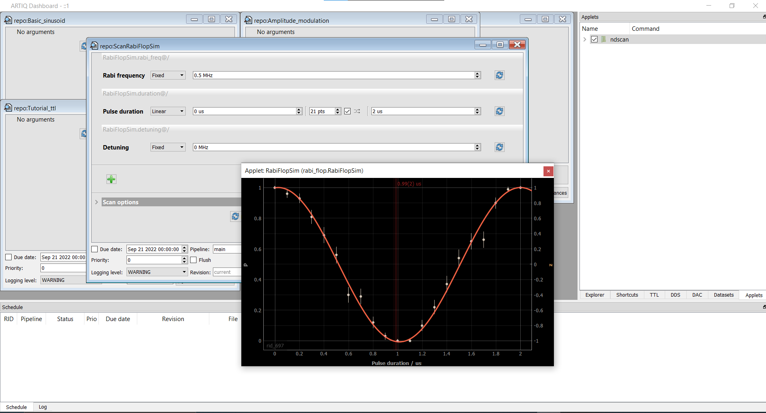

Debugging commands:
- Pinging Kasli IP
- Checking artiq_coremgmt log, artiq_coremgmt config read ip etc. (from manual)

2023/6/20
Both lld and llvm-tools were linked to anaconda channel.
Moved it to conda-forge channel. Versions have been updated to 16.0.6 and sems more stable.
lld 16.0.6 h21f6fed_0 conda-forge
llvm-tools 16.0.6 h1ab654d_0 conda-forge

I basically just prioritized conda forge channel over anaconda channel in the channel list.

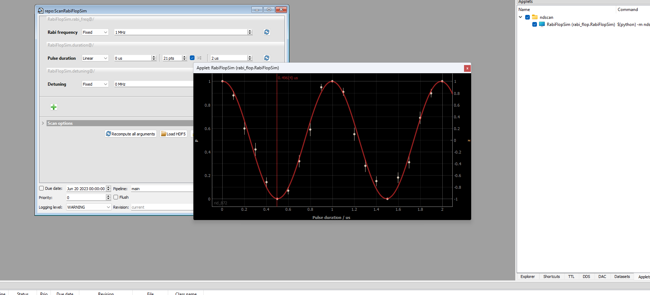

Fix binding ports and choose correct gateware to be flashed for led to work as they are not working correctly now.

